Başkent University

Department of Electrical and Electronics Engineering

EEM 214 Electronics I Laboratory

Experiment 5

Diode Clipping & Clamping Circuits

Aim:

The purpose of this experiment is to investigate the application of the diode applications in clipping and clamping circuits.

Theory:

In addition to the use of diodes as rectifiers and voltage regulators, there are a number of other interesting applications. For example, diodes are frequently used in applications such as wave-shaping circuits, detectors, protection circuits, and switching circuits. In this experiment, two widely used applications of diode circuits are investigated, namely diode limiter (clipper) circuits and diode clamping (DC Restorer) circuits.
Often in the development of electronic circuits it is required that voltages be limited in some manner to avoid circuit damage. Furthermore, the limiting or clipping of voltages can be very useful in the development of wave-shaping circuits. A typical clipper circuit is shown in Fig. 1. In this circuit the output voltage can never be greater than 3 V. The ideal diode becomes forward biased at v_{o}(t) equal to 3 V and this ties the output directly to the 3 V supply. The waveform can be clipped on the negative side by placing the series combination of a diode and power supply in parallel with the diode and power supply already shown.

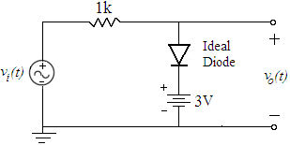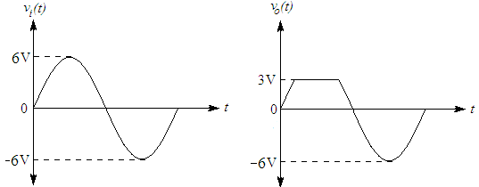

figure_1 Typical Diode Clipper Circuit Showing Input and Output Voltages
While clipper circuits are concerned primarily with limiting or cutting off part of the waveform, clampers are used primarily to shift the DC level. For example, if we have a clock signal that swings between 0V and 5V but our application requires a clock signal from -5V to 0V, we can provide the proper DC offset with a passive clamper circuit. A typical clamper circuit is shown in Fig. 2. For this circuit to work properly the pulse width needs to be much less than the RC time constant of 10ms. The input square wave with a frequency of 1 KHz and a pulse width of 0.5ms meets this requirement. The diode and power supply as shown will prevent the output voltage from exceeding 3 V (i.e., all of the region above 3 V can be viewed as a forbidden region for output voltage). Because of the time constant requirement the voltage across the capacitor can not change significantly during the pulse width, and after a short transient period the voltage across the capacitor reached a steady state offset value. The output voltage is simply the input voltage shifted by this steady state offset. Also, observe that the peak-to-peat output voltage is equal to the peak-to-peak input voltage. This is true because the voltage across the capacitor can not change instantaneously and the full change of voltage on the input side of the capacitor will likewise be seen on the output side of the capacitor.

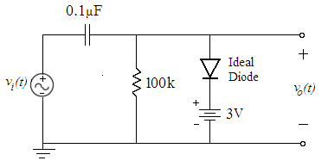

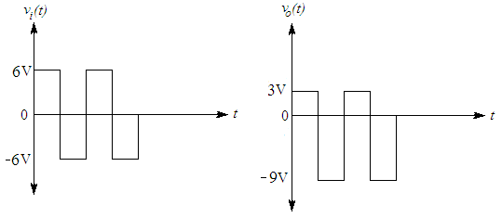

figure_2 Typical Diode Clamper Circuit Showing Input and Output Voltages

Preliminary Work:

- Review section 3.19 from the text book.

Clipper Circuits

- a. Consider the clipper circuit in Fig.3, draw the input and output voltage waveforms in same plot(explain briefly how you obtain), assume diode model is constant voltage drop, v_{i}(t)=10sin(200πt), R=1kΩ and R_{L}=47kΩ.
Construct and simulate the circuit using PSPICE and get the waveform of the input and output voltage in same plot. Vary the dc voltage and explain briefly the effects on output voltage. Check your drawing with the simulation. Does the minimum values of the input and output voltage same? Why? Explain briefly.

b. For the clipper circuit in Fig.3; reverse the diode and replace the positive DC supply with negatively DC supply and repeat the 2-a.

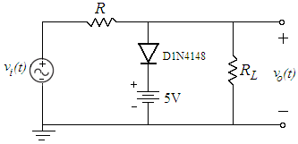
figure_3

- a. Consider the clipper circuit with zener diode in Fig.4, draw the waveforms of input voltage, output voltage and voltage across the each zener in same plot(explain briefly how you obtain), assume diode model is constant voltage drop, v_{i}(t)=10sin(200πt), R=1kΩ and R_{L}=47kΩ.
Construct and simulate the circuit using PSPICE and get the waveform of the input voltage, output voltage and voltage across the each zener diode. Check your drawing with the simulation.

b. Reverse the zener diodes(both zener) in Fig.4 and simulate in PSPICE and get the waveform of the output voltage and voltage across each zener diode. Does the output voltage changes? Why?(Explain briefly)

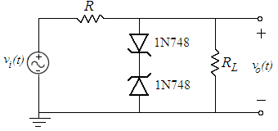
figure_4

- Design(explain briefly) the circuit, using the constant voltage drop model of diode, resistors and batteries, which have the input voltage and clipped output voltage in Fig.5. Construct and simulate the circuit using PSPICE and get the waveform of the input and output voltage. Compare the simulation result with the given output voltage. Check whether your design is correct or not.

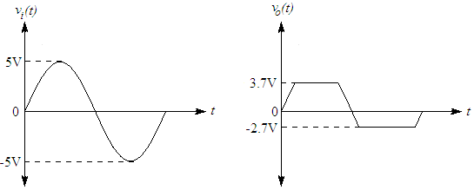
figure_5

Clamper Circuits

- a. Consider the clamper circuit in Fig.6a, draw the input and output voltage waveforms (explain briefly how you obtain), assume diode model is constant voltage drop, v_{i}(t)=10sin(200πt) and C=1μF. What is DC value of the output voltage?
Construct and simulate the circuit using PSPICE and get the waveform of the input and output voltage waveform in same plot also obtain DC(average) value of the output voltage using PSPICE add trace button. Check your drawing with the simulation.
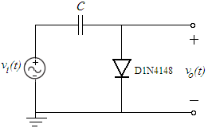
figure_6a

b. Consider the clamper circuit in Fig.6b, draw the input and output voltage waveforms (explain briefly how you obtain), assume diode model is constant voltage drop, v_{i}(t)=10sin(200πt) and C=47μF.
Construct and simulate the circuit using PSPICE and get the waveform of the input and output voltage waveform. Vary the dc voltage and explain briefly the effects on output voltage. Check your drawing with the simulation.

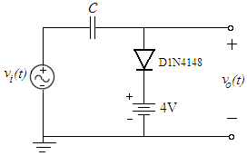
figure_6b

c. For the clamper circuit in Fig.6b; reverse the diode and repeat the 5b.

- Consider the clamper circuit with zener diode in Fig.7, draw the input and output voltage waveforms (explain briefly how you obtain), assume diode model is constant voltage drop, v_{s}(t)=2sin(200πt) and R_{L}=1kΩ. Construct and simulate the circuit using PSPICE and get the waveform of the input(v_{i}(t)) and output voltage waveform. Check your drawing with the simulation.

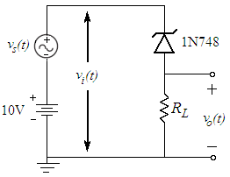
figure_7

- Read the experimental work.

Experimental Work:

- a. Setup the circuit of Fig.3. Set the input voltage signal to a sinusoid with 100 Hz frequency and 20V peak-to-peak amplitude with R=1kΩ and R_{L}=47kΩ. Obtain and plot the input and output voltage waveforms. (in DC coupling mode)

v_{in} v_{out}


b. Reverse the diode and replace the positive DC supply with negative DC supply and repeat the 1a. Does the output voltage waveform change? Why?(Explain Briefly)

v_{out}


- a. Setup the circuit of Fig.4. Set the input voltage signal to a sinusoid with 100 Hz frequency and 20V peak-to-peak amplitude with R=1kΩ and R_{L}=47kΩ. Obtain and plot the input voltage waveform, output voltage waveform.

v_{in} v_{out}


b. Reverse the upper zener and repeat the 2a. Does the output voltage change? Why?(Explain Briefly)

v_{out}


- Setup the circuit that you designed in preliminary work part_4. Set the input voltage signal to a sinusoid with 100 Hz frequency and 10V peak-to-peak amplitude. Obtain and plot the input and output voltage waveforms.

v_{in} v_{out}


- a. Setup the circuit of Fig.6a. Set the input voltage signal to a sinusoid with 100 Hz frequency and 20V peak-to-peak amplitude with C=1μF. Obtain and plot the input and output voltage waveforms.

v_{in} v_{out}

b. Setup the circuit of Fig.6b. Set the input voltage signal to a sinusoid with 100 Hz frequency and 20V peak-to-peak amplitude with C=47μF. Obtain and plot the input and output voltage waveforms.

v_{in} v_{out}

c. Reverse the diode and replace the positive DC supply with negative DC supply and repeat the 4b. Does the output voltage waveform change? Why? (Explain Briefly)

v_{out}

- Setup the circuit of Fig.8. Set the input voltage signal to a sinusoid with 100 Hz frequency and 20V peak-to-peak amplitude with R=1kΩ and C=1μF.

- Disconnect the capacitor and short circuit that two nodes. Obtain and plot the input and output voltage waveform. Vary the DC voltage separately (one at a time) and explain briefly the effects on output voltage.
Obtain and plot transfer characteristics v_{out} vs v_{in} on the oscilloscope. (X-Y mode).

v_{in} v_{out} v_{in} vs v_{out}


- Connect the capacitor. Obtain and plot the input and output voltage waveform. Vary the DC voltage separately (one at a time) and explain briefly the effects on output voltage.
Obtain and plot transfer characteristics v_{out} vs v_{in} on the oscilloscope.(X-Y mode).

v_{in} v_{out} v_{in} vs v_{out}

- Comment on changes between a. and b..

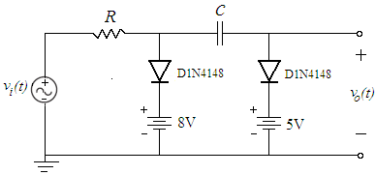
figure_8

Lab Instruments:  Breadboard  Oscilloscope  Signal Generator  DC Power Supply | Components:  2 1N4148  2 BZX55C 3V9  1 1kΩ  1 47kΩ  1 47μF  1 1μF

